Move Tank Block

# Basics

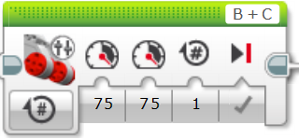

Left Motor Port

Right Motor Port

Left

Motor

Power

Right

Motor

Power

Brake when finished

Number of Rotations/Degrees/ Seconds

MENU

# Move Tank – Menu

## On for Rotations

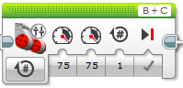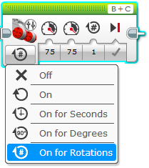

## Rotations Options

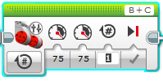

Type your Rotations

Same as before

Same as before